

**National University of Computer and Emerging Sciences**



AI Killing Jobs for People

**FYP Team**

Talha Majeed…………21L-5292

Hamza Arfan…………21L-5222

Abdul Samad…………21L-5089

Mahnoor Ahmad...…..…21L-5293

Zaki Qasim….………21L-7642

**Supervised by**

**<** Huma Malik**>**

**FAST School of Computing**

**National University of Computer and Emerging Sciences**

**Lahore, Pakistan**

**November, 2023**

**Abstract**

This report presents an in-depth examination of the impact of Artificial Intelligence (AI) on employment, encapsulating the multifaceted effects of this transformative technology in the modern workforce. The advent of AI has revolutionized various industry sectors, catalyzing efficiency and innovation, while simultaneously posing challenges in terms of job displacement and the evolving nature of work. This analysis delves into the dual aspects of AI's influence, highlighting the efficiency and growth it brings, alongside the potential risks of job automation, particularly in routine-based industries.

The core of this report focuses on proactive strategies to mitigate the disruptive aspects of AI. It explores the development and implementation of upskilling platforms, ethical AI frameworks, and AI-driven job matching algorithms as essential measures to address the skill gaps created by automation and to ensure equitable employment opportunities. These solutions emphasize the importance of adapting workforce skills to the evolving demands of an AI-enhanced job market, ensuring ethical application of AI, and fostering a balanced approach to automation and human labor.

Furthermore, the report underscores the crucial role of collaboration among stakeholders, including policymakers, businesses, and educational institutions, to formulate comprehensive strategies that balance the benefits and challenges of AI in employment. By examining the implications of AI on various job roles and industries, this report provides insights into the ways AI is reshaping the employment landscape, emphasizing the need for a multifaceted approach that addresses ethical concerns, skills development, and policy interventions.

In summary, the report articulates the complexities of AI integration into the workforce, presenting a nuanced perspective on how AI can be harnessed to enhance employment opportunities while responsibly managing its challenges. It serves as a critical resource for understanding the dynamic interplay between AI and employment, guiding stakeholders in navigating the evolving job market effectively.

Table of Contents

Chapter 1: Introduction 1

1.1 Purpose of this Document 1

1.2 Intended Audience 1

1.3 Definitions, Acronyms, and Abbreviations 1

Chapter 2: Project Vision 2

2.1 Problem Domain Overview 2

2.2 Problem Statement 2

2.3 Problem Elaboration 2

2.4 Goals and Objectives 3

2.5 Project Scope 3

Chapter 3: Literature Review / Related Work 4

Chapter 4: Software Requirement Specifications 12

4.0 Introduction: 12

4.1 List of Features 12

4.2 Functional Requirements 12

4.2.1 User Registration and Authentication Module 12

4.2.2 Reskilling and Upskilling Module 13

4.2.3 Ethical AI Framework Module 13

4.2.4 Job Matching Module 13

4.4 Non-Functional Requirements 14

4.5 Assumptions 14

4.6 Hardware and Software Requirements 14

4.7 Use Cases 14

4.7.1 User Registration 14

4.7.2 User Authentication 14

4.7.3 Skill Assessment 15

4.7.4 Ethical Guideline Formulation 15

4.7.5 Job Matching 15

4.7.6 Program Recommendations 15

4.8 Graphical User Interface 15

Chapter 5: Software Design 16

5.1: Ethical AI Framework Module: 16

5.1.1: Use Case Diagram: 16

5.1.2: Sequence Diagram: 16

5.1.3: Entity-Relationship Figure: 16

5.2: Reskilling and Upskilling Module: 16

5.2.1: Use Case Diagram: 16

5.2.2: Sequence Diagram: 16

5.2.3: Entity-Relationship Figure: 17

5.3: User Registration and Authentication Module: 17

5.3.1: Use Case Diagram: 17

5.3.2: Sequence Diagram: 17

5.3.3: Entity-Relationship Figure: 17

5.4: Job Matching Module: 17

5.4.1: Use Case Diagram: 17

5.4.2: Sequence Diagram: 17

5.4.3: Entity-Relationship Figure: 17

Chapter 6: Survey Insights 19

6.1. Objective of Survey: 19

6.2. Target Audience Selection: 19

6.3. Distribution Method: 20

6.4. Data Collection: 20

Chapter 7: High Level And Low Level Design 21

7.1. High Level and Low Level Design: 21

Chapter 8: Implementation and Test Cases 21

8.1. Implementation and Test Cases: 22

Chapter 9: Conclusion 23

References 24

List of Figures

Figure 1: Response for Question 1 29

Figure 2: Response for Question 2 30

Figure 3: Response for Question 3 30

Figure 4: Response for Question 4 31

Figure 5: Response for Question 5 31

Figure 6: Response for Question 6 32

Figure 7: Response for Question 7 32

Figure 8: Response for Question 8 33

Figure 9: Response for Question 9 33

Figure 10: Response for Question 10 34

# Introduction

The development of artificial intelligence has greatly changed numerous aspects of daily life and opened up new possibilities and efficiencies for everything. However, this progress has also raised concerns about its impact on employment, as machines and algorithms increasingly perform tasks traditionally carried out by humans. In today's society, artificial intelligence (AI) covers practically every aspect of life and is expected to completely replace humans in the near future.This report digs into the complex issue of AI's influence on the jobs of people, exploring the challenges and consequences linked with the automation of tasks and includes potential solutions to the problem.

## Purpose of this Document

The purpose of this document is to offer a countermeasure to the growing danger to human employment. Potential methods to reduce the issue of AI taking jobs away from people will be discussed.The report includes requirements of the solution as well as the design, findings, and analysis.

## Intended Audience

The report's intended audience includes academics, professionals in industry, people who are responsible for making policies and anybody who wants to learn more about how automation is affecting jobs. It is essential to understand the possible solutions of the problem in order to make well-informed decisions, create efficient policies and to prepare individuals to adjust to the changing work environment and employment.

## Definitions, Acronyms, and Abbreviations

For the purpose of clarity and better understanding the full forms of some abbreviations used in the document are given below

**AI:** Artificial Intelligence

# Project Vision

**Introduction:**

The project's goal is to address the growing societal worry that automation is replacing human labor in the workforce. The project involves a thorough analysis of the issue as well as solutions to lessen it and maintain a balance between employment and automation.

## Problem Domain Overview

AI with its intervention in the workforce has started raising many concerns for the individuals and the employment sectors. Automation is replacing traditional work structures in the world and how this is affecting different people, businesses, etc. The solutions to deal with this problem include Upskilling Platforms, Ethical AI Frameworks, and Job Matching Algorithms.

Upskilling Platforms : This aspect of the system creates AI-driven online learning environments. These platforms evaluate present skill sets, identify knowledge gaps, and suggest customized upskilling programmes based on the particular needs of each worker. Through the use of sophisticated algorithms, the system directs users towards becoming knowledgeable in areas that are more resistant to automation.

Ethical AI Framework : This component focuses on developing fairness in AI systems, making sure decision-making algorithms are transparent.

Job Matching Algorithms : AI-driven job matching algorithms are included into the system to make the job finding process easier. These algorithms match workers with job opportunities that are in line with their talents and goals by taking into account their preferences, unique skill sets, and the changing structure of the job market.

## Problem Statement

The interference of AI in the work sector is becoming a bigger problem these days. Human labor faces the risk of having their work soon taken over by artificial intelligence. The challenge at hand is to properly handle the negative effects of AI-caused job displacement, such as the decline in hiring opportunities, the creation of skill gaps. This problem statement intends to direct the creation of a comprehensive approach that includes the use of advanced job matching algorithms, the creation of ethical AI frameworks, and customized upskilling programmes.

## Problem Elaboration

The problem of loss of employment due to automation requires a careful analysis of a number of interconnected elements. First, the rapid adoption of AI threatens to diminish traditional employment opportunities Second, the introduction of new roles means that there are large skill gaps in the workforce that need to be filled, leading to the need for reskilling programmes. Since biased algorithms in AI systems have the potential to worsen social injustices, emphasizing the necessity of responsible AI frameworks. Furthermore, it can also result in economic inequality in society.

## Goals and Objectives

Following are the goals and objects of the report:

Go through the previous work done on this topic in order to understand different viewpoints

Examine how with time AI technology has entered different industries and its effects on employment.

Create a set of moral standards to direct the creation and application of AI systems.

Implement AI driven job finding algorithms that match workers with work opportunities that align with their skills and talent.

Create AI-powered learning systems that provide recommendations for reskilling and upskilling programmes based on an objective assessment of each learner's skills.

## Project Scope

The scope of the project involves creating an integrated AI solution, promoting ethical AI behavior, and helping skill development and job matching to minimize unemployment caused by automation

**Conclusion**

To conclude, this chapter provides a strategic roadmap for developing a significant solution. This chapter serves as the foundation for later chapters and directs the creation of innovative approaches intended to enable individuals and companies to deal with the complex relationship between automation and employment.

# Literature Review / Related Work

**How Will Artificial Intelligence Affect Jobs 2023-2030**

**Author:** Mark Talmage-Rostron

**Reference:** <https://www.nexford.edu/insights/how-will-ai-affect-jobs>

**Introduction:**

The impact of artificial intelligence (AI) on jobs between 2023 and 2030 is a topic of significant debate and analysis. As AI technologies like ChatGPT and others gain prominence, their influence on the job market is becoming increasingly evident. According to McKinsey Global Institute, AI could add about $13 trillion to global economic activity by 2030, translating to a 1.2% increase in GDP growth per year. This growth is attributed mainly to automation replacing labor and spurring innovation in products and services (McKinsey Global Institute, 2023).

**Review:**

Forbes and Bernard Marr & Co emphasize AI's potential transformative impact on society, projecting enhancements in productivity, healthcare, and education. AI's ability to solve complex problems and simplify daily life is expected to affect various job sectors and industries (Forbes, 2023; Bernard Marr & Co, 2023). Goldman Sachs's report indicates that AI could replace the equivalent of 300 million full-time jobs, impacting work tasks in the US and Europe significantly. This could lead to a productivity boom and an increase in the global value of goods and services by 7%. However, it's noted that educated white-collar workers earning up to $80,000 a year are most susceptible to workforce automation (Goldman Sachs, 2023). Certain job roles, particularly those involving repetitive tasks, are more prone to automation. These include roles such as customer service representatives, receptionists, accountants, salespeople, data analysts, warehouse workers, insurance underwriters, and retail workers. On the other hand, jobs less likely to be affected by AI include those requiring complex human interactions and decision-making, such as teaching, legal professions, executive management, human resources, mental health care, surgery, computer system analysis, and creative fields like writing and art. To adapt to the AI-driven job market, experts advise focusing on acquiring new skills, particularly technical skills relevant to AI and machine learning. Developing soft skills, embracing lifelong learning, being agile, and specializing in niche areas are crucial strategies to remain competitive in the era of AI (LinkedIn, 2023).

**Conclusion:**

In conclusion, while AI's integration into various industries, including logistics, manufacturing, and cybersecurity, demands a proactive approach to skill development and adaptation, the overall sentiment leans toward AI being a positive force in the job market.

Embracing AI's potential and preparing for its challenges are essential for thriving in the evolving job market.

**Artificial Intelligence, Growth, and Employment: The Role of Policy**

**Authors:** Philippe Aghion, Céline Antonin and Simon Bunel

**Reference**: [ttps://sciencespo.hal.science/hal-03403370/file/2020-aghion-artificial-intelligence-growth-andemployment.pd](https://sciencespo.hal.science/hal-03403370/file/2020-aghion-artificial-intelligence-growth-andemployment.pd)

**Introduction:**

The literature review conducted by Aghion, Antonin, and Bunel delves into the intricate interplay between Artificial Intelligence (AI), automation, economic growth, and employment. Central to their exploration are the pivotal roles of institutions and policies in shaping the outcomes of these technological advancements. The review navigates through key themes such as AI's potential to propel economic growth by substituting labor with capital, the necessity of appropriate competition policies, and various models suggesting that automation can enhance economic growth by replacing finite labor with theoretically unlimited capital. Additionally, the study scrutinizes the dual impact of AI on employment, drawing from recent literature and empirical analysis of robotization in France, with a particular focus on the period from 1994 to 2014. As the authors emphasize, the findings underscore the nuanced effects on employment, especially for non-educated workers, underscoring the critical importance of tailored labor market and educational policies.

**Review:**

The literature review by Aghion, Antonin, and Bunel explores the impact of Artificial Intelligence (AI) and automation on economic growth and employment, emphasizing the crucial role of institutions and policies. Key themes include AI’s potential to drive economic growth by substituting labour with capital, the necessity of suitable competition policies for improved growth, and various models indicating that automation can contribute to economic growth by replacing finite labour with theoretically unlimited capital.

The review also discusses the dual impact of AI on employment through an overview of recent literature and an empirical analysis of robotization in France (1994-2014). Findings reveal a decrease in overall employment, with non-educated workers more adversely affected, highlighting the importance of labour market and educational policies in mediating the impact of AI and automation on employment. The study underscores the significance of appropriate policies and institutions in maximizing the benefits of AI and automation on growth and employment. It warns against inappropriate policies leading to negative consequences, especially for less-educated workers, and emphasizes the need for forward-looking policies that adapt to technological changes. Additionally, the review makes a distinction between automation in the production of goods and services and its impact on the generation of new ideas, noting the increasing influence of AI in the latter. It discusses how AI and automation can maintain positive long-run growth rates in knowledge production despite potential diminishing returns. The regional analysis and global comparisons, particularly the detailed examination of robot impact on employment in France compared to the United States using the methodology of Acemoglu & Restrepo (2017), are highlighted. The methodological approach involves using various models and empirical data, incorporating information from the International Federation of Robotics, and considering various control variables in regression analyses.

In conclusion, the review highlights the dual nature of AI and automation, acknowledging their potential to stimulate economic growth but emphasizing a nuanced impact on employment. The key factors influencing outcomes include educational and Labor market policies. The literature on AI's job impact suggests a transformative rather than solely destructive effect, creating new opportunities in technology and AI-driven fields while posing risks to routine tasks. Skill and education play a crucial role, with higher-skilled jobs potentially growing and lower-skilled ones being more susceptible to automation. The impact varies across industries, with manufacturing experiencing more automation and others like healthcare and education less affected. While AI can contribute significantly to economic growth, policies focusing on education, upskilling, and reskilling are deemed essential. Regional variations in impact are influenced by economic structures, technology adoption rates, and demographic profiles. Uncertainty remains about long-term job market impacts, ranging from significant displacements to the creation of new job categories. In summary, AI is seen as a substantial driver of job transformation rather than a mere job killer, and its net impact depends on factors like technological adoption pace, workforce characteristics, sector specifics, and the effectiveness of policy responses, necessitating adaptation for success in an AI-augmented job market.

**Conclusion:**

In summary, the comprehensive review underscores the intricate dynamics surrounding the impact of AI and automation on economic growth and employment. It emphasizes the indispensable role of institutions and policies in maximizing the benefits of these technological advancements. While acknowledging the potential of AI to drive economic growth, the review underscores the mixed impact on employment, highlighting the need for adaptive policies that consider educational and labor market dynamics. The transformative rather than solely destructive nature of AI's impact on jobs is a key takeaway, with the creation of new opportunities in technology and AI-driven sectors counterbalanced by risks to routine tasks. The significance of skill and education is highlighted, with implications for different job categories and industries. Overall, the review calls for forward-looking policies that align with technological changes, ensuring that the potential of AI is harnessed for positive economic outcomes, while mitigating negative consequences, especially for vulnerable segments of the workforce.

**IS ARTIFICIAL INTELLIGENCE KILLING ARTISTIC SKILLS IN DESIGNERS?**

**Authors: Akash** Anant Alegaonkar (Assistant Professor, Department of Design, Vishwakarma University, Pune, Maharashtra, India)

**Reference:** <https://tinyurl.com/mr2cyh4y>

**Introduction:**

Throughout the history of mankind, it is seen that every newly emerging technology casts and leaves a big impact on human society. Artificial Intelligence (AI) which is a newly emerging technology, is now being used in almost every field of life and is helping humans and organizations in getting their work done with high success and work done ratio. On one hand it is killing jobs of multiple people daily as well as it has a great impact on the design industry as well. The use of AI generative tools has significant impact in design evolution but there exist concerns regarding the potential to stifle artistic skills. The designer as well as students use ai generative tools along with their empathy and creative skills to make something visually appealing. Since AI doesn’t develop empathy and innovative creativity the designers are of the point of view that their jobs are safe. The symbiosis of humans and their emotional connection with each other will only create captivating designs.

**Review:**

Artificial Intelligence (AI) is a newly emerging technology which is being used in almost every field around the globe and design industries are not an exception to it. There are no doubts that AI is being widely used by students as well as designers for educational and work purposes. Many designers do not use AI tools at all but still a person could see that virtual reality, augmented reality and artificial intelligence are now overpowering humans in almost every sector.AI generative tools have unique features which cover every aspect of visualizations. For example, AI generated tools like Dall-E generate images from text descriptions, Midjourney and Stable Diffusion create new product designs by using provided algorithms, Vizcom translates 2D designs into 3D. But the main Question is that if AI is performing so many jobs then there come a question in almost every designer's mind. What will be our role in the industry in the future? If AI is used for every design related task, will it be harmful for our jobs?

**Objectives:**

• To analyze challenges of using AI for designers

• To analyze strength, weakness, opportunities, and threats of using AI (SWOT Analysis)

**IMPACT OF AI ON DESIGN INDUSTRY:**

AI’s advancement in machine learning and neural learning algorithms sparks concerns about replacing designers but Miklos Philips contradicts it by stating that the robots won't be replacing humans but will be aiding them in their work. In product design, AI proves useful across research, 3D rendering, and even in the final production stages. Use of AI tools enhances product quality and assists human workers and aids in smart manufacturing Aswell. It also helps in data analysis and assists the designers in making faster and cost-effective design creation. AI generated seven million unique Nutella packaging designs, all swiftly sold in Italy, showcasing its ability to produce diverse designs of high quality (Aouf, 2017; Italia, 2017).

**Usage of AI in Design Industry:**

Ai aids both the students and professionals by processing specific data for the tasks and also ensures accuracy as well. The AI not only facilitates efficient designing but also assists in product localization across languages and helps in catching defects in designs as well. ChatGPT is a new AI chat bot that gathers diverse information from all around the globe and uses that information to generate meaningful content for its users.

**Role Of AI Designer:**

The AI designers collaborate with the product designers to display and showcase their AI prototypes and the data visualizations which helps in project viability for further research. They also develop AI based applications and also work with the engineers for data collection and design tools to bridge the gap between technology and the users. This helps in making the users know about the advent of evolving technologies.

**Conclusion:**

Without any kind of doubt, it is known that to create a powerful and impactful design there are 2 aspects that need to be in it:

1.Human empathy

2.Creativity

Both aspects cannot be taught to a machine keeping in mind the limitations of which our modern and current machines are working on. Emotional intelligence cannot be taught to machines as they require development of communication as a skill and being empathetic with other people which AI machines cannot perform. Until these 2 aspects are not fulfilled by the AI machines the jobs of designers are completely safe. Designers until now cannot be replaced by AI machines and their jobs are safe for some years to come but they need to adapt themselves to the use of AI and new technologies in making designs much more powerful and responsive. Ultimately machines can only process data, which is fed into them, it cannot process more or less than it. Further research can be done as well on how to develop strategies and develop commands with emotional intelligence so that AI can be used much more effectively.

**Artificial Intelligence and the Future of Work: A Functional-Identity Perspective**

**Author:** Eva Selenko , Sarah Bankins, , and Simon Lloyd D. Restubog

**Reference:** <https://journals.sagepub.com/doi/full/10.1177/09637214221091823>

**Introduction:**

The impact of the implementation of artificial intelligence (AI) on workers’ experiences remains under examined. Although AI-enhanced processes can benefit workers (e.g., by

assisting with exhausting or dangerous tasks), they can also elicit psychological harm (e.g., by causing job loss or degrading work quality). Given AI’s uniqueness among other technologies, resulting from its expanding capabilities and capacity for autonomous learning, we propose a functional-identity framework to examine AI’s effects on people’s work-related self-understandings and the social environment at work. We argue that the conditions for AI to either enhance or threaten workers’ sense of identity derived from their work depends on how the technology is functionally deployed (by complementing tasks, replacing tasks, and/or generating new tasks) and how it affects the social fabric of work. Also, how AI is implemented and the broader social-validation context play a role. We conclude by outlining future research directions and potential application of the proposed framework to organizational practice.

**Review:**

AI-enhanced processes can replace various cognitive and manual tasks previously done by humans, including (a) arduous and repetitive tasks (e.g., pattern recognition, stock refilling), (b) other routine tasks (e.g., scheduling, diagnostics, data search), and (c) more highly skilled tasks associated with complex decision making (e.g., AI-automated financial, legal, or policing decisions; customer service). Such replacement brings additional identity challenges, over and above those presented by AI that complements current tasks. When AI replaces tasks, workers are no longer able to enact task-related professional self-understandings. This can disrupt a sense of self-continuity and possibly frustrate the satisfaction of other related identity functions that carry out the replaced tasks previously served (e.g., gaining self-esteem, certainty, meaning; Endacott, 2021). However, if the replacement of certain tasks by AI enables workers to get closer to their aspired identities (e.g., because it removes an obstacle to accessing identity-relevant functions by ameliorating a high failure rate or social stigma), workers will find it easier to change their identities, and the replacement will be more readily accepted (Endacott, 2021). The replaced tasks may also reshape the organization of remaining work. For example, interacting with or being managed by a self-learning, unintelligible algorithmic process that acts in a quasihuman way may feel uncanny (Schafheitle et al., 2020). Moreover, if decisions are perceived as being made without appropriate contextual information, or if they are perceived as incorrect or arbitrary, they may not be trusted (Raisch & Krakowski, 2021), which can result in feelings of alienation or dehumanization. If the replacement of tasks is accompanied by the replacement of humans, this will also alter the social fabric of work, which, in turn, will affect how remaining workers can validate their existing work-related identities (Endacott, 2021). Workers who lose significant aspects of their jobs, or their job roles, will face the greatest identity challenge. How can they protect their self-esteem and achieve a sense of self continuity and self-verification if the social self-categorizations enabling those functions no longer exist?

**Conclusion:**

Navigating the evolving landscape of AI and employment requires a balanced perspective. The potential for economic growth and innovation is substantial, but it coexists with challenges related to job displacement and the need for reskilling. Policymakers, businesses, and individuals must collaborate to establish frameworks that ensure the equitable distribution of benefits and facilitate the acquisition of skills aligned with the demands of the AI-driven future.

**AI, Automation, and New Jobs**

**Introduction:**

This literature review is about the article "AI, Automation, and New Jobs" by Jaures Badet. He examines how the conversation about automation and AI is developing and puts it against the COVID-19 pandemic. The article explores projections for the years 2016–2030, looking at possible workforce creation and displacement. It draws on a variety of sources, including the influential work of Manyika and Sneader (2018).

**Review:**

The author of "AI, Automation, and New Jobs" Jaures Badet, from the Economics Department at Necmettin Erbakan University in Konya, Turkey, examines the changing conversation about the incorporation of automation and artificial intelligence (AI) into the workforce in great detail. The article starts off by placing the conversation within the COVID-19 epidemic and emphasizing how much more relevant technology is in dealing with today's issues. The article presents varied predictions on the possible displacement and creation of employment by automation throughout the period 2016–2030 (15 percent of the global workforce, or around 400 million workers displaced), drawing on a variety of sources, including the works of Manyika and Sneader (2018).

The article explores complex viewpoints of automation's effects, highlighting the variability in those effects according to educational attainment and industry-specific factors. Citing research by Arntz et al. (2016) and Graetz and Michaels (2015), among others, the author emphasizes how jobs with lower skill levels are more susceptible to automation. The article also presents the idea of productivity effects and displacement effects, explaining how these impacts can be balanced by other economic factors like productivity, capital accumulation, and the creation of new jobs, even though automation may result in a decrease in the demand for labor.

The article also emphasizes the possible benefits of automation, particularly the creation of new, more sophisticated tasks and occupations, a noteworthy contribution. Drawing from the research of Atkinson and Wu (2017) as well as Manyika and Sneader (2018), the author makes the argument that automation might lead to a net increase in employment rather than the widespread concerns of significant job losses. This is especially relevant given that humans and machines are working together, as demonstrated by the impending introduction of autonomous vehicles, about which the article makes predictions about the displacement of conventional positions and the creation of new, complex employment. To sum up, Jaures Badet's article offers a thorough synthesis of various points of view, actual data, and

theoretical frameworks, providing insightful information about the complex interplay between automation, artificial intelligence, and employment dynamics.

**Conclusion:**

To conclude, Badet provides a thorough synthesis of conceptual frameworks and data from experiments that provides insightful understanding of the complex interplay between automation, artificial intelligence, and employment dynamics. The article challenges the widespread fears of mass job losses by arguing that automation may actually result in a net increase in employment through human-machine collaboration.

# Software Requirement Specifications

## 4.0 Introduction:

In this chapter, we have listed all the requirements for the proposed software.The goal is to make things clear enough for any reader to follow the specified requirements and develop and replicate the system or results.

## 4.1 List of Features

The system consists of following three features

**Upskilling Platforms:**

* Registration and Authentication of User
* Evaluation of skills and detection of knowledge gaps.
* Customized recommendation engine for upskilling programs.

**Ethical AI Frameworks:**

* Creation of ethical guidelines for AI development and deployment.
* Combining algorithmic decision-making with ethical considerations.
* Tools for real-time monitoring that identify and minimize bias.

**Job Matching Algorithms:**

* Establishment of user profiles with preferences and set of skills.
* AI-driven job matching algorithms considering individual and market dynamics.

## 

## 4.2 Functional Requirements

### 4.2.1 User Registration and Authentication Module

* Functions
* User registration and login
* Secure mechanisms for user authentication
* Storage
* Database to store user credentials

### 

### 4.2.2 Reskilling and Upskilling Module

**Functions**

* Quizzes for User’s skills assessment
* Identify the knowledge gap
* Customized program recommendations
* Storage
* Profile of User’s skills
* Program database that aligns skills and content.

### 4.2.3 Ethical AI Framework Module

**Functions**

* Formulation of Ethical Guidelines
* Algorithmic incorporation of ethical concerns.
* Tools for identifying and reducing bias in real time.

**Storage**

* Ethical guidelines repository.
* Bias detection logs and mitigation strategies.

## 

### 4.2.4 Job Matching Module

**Functions**

* Establishment of a user profile with preferences.
* AI driven algorithms for matching jobs
* Engine for recommending jobs.

**Storage**

* User preferences for jobs.
* Job database with skill requirements.

## 4.4 Non-Functional Requirements

**Security**

* Encryption of User credentials and data
* Usability
* Interfaces that are easy to navigate and are user-friendly
* Responsive system performance during peak usage.

## 4.5 Assumptions

* Users have a good internet connection
* Users possess some basic AI knowledge

## 4.6 Hardware and Software Requirements

**Hardware Requirements**

* A device with processing capabilities
* Internet Connection

**Software Requirements**

* Web Browser
* Server for data storage and retrieval

## 4.7 Use Cases

### 4.7.1 User Registration

This use case deals with the user registration process. User and System will be the actors interacting with it.

### 

### 4.7.2 User Authentication

This use case deals with the authentication of credentials entered by the user . System will be the actor interacting with it.

### 4.7.3 Skill Assessment

This use case deals with the assessment of users skills, filling of quiz and evaluation of the quiz. User and System will be the actors interacting with it.

### 4.7.4 Ethical Guideline Formulation

This use case deals with the creation of ethical guidelines for the development of AI.

### 4.7.5 Job Matching

This use case deals with the matching of the job on the basis of user’s preferences and skills

### 4.7.6 Program Recommendations

This use case deals with suggesting programs to user keeping in mind his skills and preferences so that he can further enhance his/her skills

## 4.8 Graphical User Interface

Graphical User Interface will be implemented for each user interacting page i.e. user registration, skill assessment, ethical guideline formulation, job matching, and program recommendations.

**Conclusion:**

In conclusion, Chapter 4 provides a road map for creating a reliable and efficient system by carefully outlining the Software Requirements Specifications (SRS) for the suggested solution.

# Software Design

**Introduction:**

The design phase of the project involved utilizing various Unified Modelling Language (UML) diagrams to model and design the system's structural and operational aspects.

## 5.1: Ethical AI Framework Module:

### 5.1.1: Use Case Diagram:

Actors: System, User

**Use Cases:**

Formulation of Ethical Guidelines

Algorithmic incorporation of ethical concerns.

Tools for identifying and reducing bias in real time.

### 5.1.2: Sequence Diagram:

Illustrates the sequence of interactions during the formulation of ethical guidelines, algorithmic incorporation, and real-time bias reduction.

Shows the flow of information between the user and the system, emphasizing real-time monitoring.

### 5.1.3: Entity-Relationship Figure:

This module may not heavily rely on traditional database relationships, but it could have tables for storing ethical guidelines, bias detection logs, and mitigation strategies.

## 5.2: Reskilling and Upskilling Module:

### 5.2.1: Use Case Diagram:

Actors: System, User

**Use Cases:**

Quizzes for User’s skills assessment

Identify the knowledge gap

Customized program recommendations

### 5.2.2: Sequence Diagram:

Represents the flow of actions during skills assessment, knowledge gap identification, and program recommendation.

Focuses on the dynamic interaction between the user and the system in assessing skills and recommending suitable upskilling programs.

### 5.2.3: Entity-Relationship Figure:

Tables could include user profiles, storing information about users' skills, and a program database aligning skills with content.

## 

## 5.3: User Registration and Authentication Module:

### 5.3.1: Use Case Diagram:

Actors: System, User

**Use Cases:**

User registration and login

Secure mechanisms for user authentication

### 5.3.2: Sequence Diagram:

Demonstrates the steps involved in user registration, login, and secure authentication.

Emphasizes the secure flow of information during the registration and login processes.

### 5.3.3: Entity-Relationship Figure:

The primary focus is on a database to store user credentials securely. This may include tables for user profiles, ensuring the storage of necessary registration information.

## 5.4: Job Matching Module:

### 5.4.1: Use Case Diagram:

Actors: System, User

**Use Cases:**

Establishment of a user profile with preferences.

AI-driven algorithms for matching jobs

Engine for recommending jobs.

### 5.4.2: Sequence Diagram:

Illustrates the steps involved in creating user profiles, the application of AI-driven algorithms for job matching, and the recommendation engine's functioning.

Highlights the dynamic interactions between the user and the system during the job matching process.

### 5.4.3: Entity-Relationship Figure:

Tables may include user preferences for jobs and a job database with skill requirements.

In summary, each module is designed to cater to specific functionalities, and the use case diagrams help illustrate the interactions between the users and the system, ensuring a clear understanding of the system's behavior. Sequence diagrams provide a detailed look at the chronological order of activities, and entity-relationship figures showcase the data structures associated with each module.

**Conclusion:**

To conclude, the software design phase provides a comprehensive foundation for subsequent development stages. The use of UML diagrams ensures clarity in understanding user-system interactions, chronological activity flow, and associated data structures. This meticulous design approach aligns with the intended objectives of the proposed system, laying the groundwork for effective implementation.

# Survey Insights

## 6.1. Objective of Survey:

The survey's main objectives encompass a comprehensive examination of AI's current and future impact on employment. It aims to determine how AI is altering job trends, specifically focusing on identifying automated roles and their effects on the workforce. The vulnerability of routine-based industries to job displacement due to AI automation is a focal point, exploring whether these sectors face heightened susceptibility. Additionally, the survey delves into the direct impact of AI on specific job roles like telemarketing and data entry, seeking to discern the extent of their transformation. Concerns surrounding potential job loss due to AI are addressed, aiming to discern whether these apprehensions are based on speculation or prevailing trends. Furthermore, the survey investigates whether AI not only replaces jobs but also generates new opportunities, particularly in cutting-edge fields such as data science and AI development. It highlights the necessity for workers to adapt their skill sets to the evolving labor market influenced by AI and evaluates the evolving demand for skills like critical thinking and adaptability. Other aspects encompass the examination of the ethical implications of AI development, the role of governmental policies in controlling AI's impact, corporate responsibilities in supporting affected workers, organizational initiatives in response to AI challenges, adaptation of educational systems, future job market uncertainties, and the potential need for global collaboration to effectively manage AI's impact on employment. Each topic contributes to a broader understanding of AI's influence on work dynamics, emphasizing the complexities involved and the necessity for a comprehensive strategy to navigate this transformative change effectively.

## 6.2. Target Audience Selection:

**1. Employees Across Various Industries:**

* 1. Technology Sector: Including those working in AI development, data science, software engineering, etc.
  2. Routine Task-based Industries: Such as manufacturing, logistics, customer service, etc., where AI automation is expected.
  3. Professional Services: Including sectors like law, healthcare, finance, and education, where AI is increasingly being used.

**2.Business Leaders and Managers:**

* 1. Executives and Decision Makers: From companies that are implementing or planning to implement AI solutions.
  2. Small Business Owners: Who may face different challenges and opportunities with AI compared to larger corporations.

**3.AI Researchers and Developers:**

* 1. Academics and professionals working in the field of AI and machine learning, who can provide insights into future trends and technological capabilities.

## 

## 6.3. Distribution Method:

This survey was conducted online on google form. It was distributed using links and QR code to different people of relevance from industry.

## 6.4. Data Collection:

A total of 40 responses were recorded and the data was compiled my google forms

**Summary:**

The survey, encompassing insights from 40 respondents, underscores the palpable impact of AI across various industries. A significant majority, around 55%, perceive a tangible effect of AI on their current roles, with specific concerns prevalent among routine-based industries where about 65% anticipate potential job displacement. Notably, tasks within sectors like telemarketing and data entry have felt the effects of AI, with approximately 40% and 30% respectively influenced by automated processes. These observations align with persistent worries, as 60% of participants express concerns about AI potentially replacing jobs across different industries. Despite these anxieties, there's a silver lining in the form of a 30% increase in job opportunities, particularly within burgeoning fields like data science. Nonetheless, there's a prevailing consensus among 70% of professionals emphasizing the critical need for proactive skill development to adapt to the evolving job market influenced by AI. While businesses acknowledge a 15% increase in productivity post-AI integration, half of them grapple with challenges related to job displacement. These findings underscore the imperative not only for skill adaptation but also for ethical oversight and potential governmental intervention to ensure equitable treatment of workers amidst AI-induced changes.

# High Level And Low Level Design

**Introduction:**

The integration of AI in industries has led to a thorough examination of its impact on employment, employing a dual-level approach. The high level focuses on analyzing AI's effects on job trends, identifying automated roles and their implications across diverse sectors. Simultaneously, the low-level approach concentrates on building an efficient technological infrastructure, addressing user-centric needs and understanding AI's employment impact.

## 7.1. High Level and Low Level Design:

The design approach for assessing AI's influence on employment encompasses both high-level and low-level considerations. At a high level, the focus is on thoroughly examining AI's impact on job trends, particularly in identifying automated roles and their effects across diverse industries, from technology to routine task-based sectors like manufacturing and professional services. This entails evaluating the direct influence of AI on specific job roles, understanding concerns about potential job displacement, and exploring the emergence of new job opportunities. The target audience selection spans employees, business leaders, and AI researchers to gather comprehensive insights. Using Google Forms, the data collection method garnered 40 responses to address survey questions probing AI's effects on employment, revealing trends, concerns, and opportunities. On the low-level side, the technological infrastructure aims for efficiency by employing modern UI frameworks, responsive design principles, and optimized code execution. The design ensures a user-centered approach, focusing on intuitive interfaces, fast analysis, and resource efficiency to cater to user needs while comprehensively analyzing AI's impact on employment. Additionally, the low-level design emphasizes scalability and adaptability in both UI responsiveness and server architecture, accommodating different learning styles and evolving job markets influenced by AI.

**Conclusion:**

The comprehensive assessment of AI's impact on employment hinges on the interplay between high-level and low-level design approaches. This involves analyzing macroscopic job trends and disruptions across industries, alongside a meticulous examination of technological frameworks and user-centric aspects. The amalgamation of these insights underscores the importance of adaptability and a user-centric approach in addressing the evolving job market dynamics shaped by AI advancements.

# Implementation and Test Cases

**Introduction:**

As technological advancements in artificial intelligence (AI) continue to reshape industries, the examination of AI's impact on employment becomes increasingly critical. This report endeavors to delve into the transformative effects of AI on job markets, exploring the potential for job displacement, the emergence of new roles, and the requisite adaptation of skills in a dynamic workforce. The report aims to provide insights into the multifaceted dimensions of AI's influence on employment, considering both high-level conceptualization and low-level implementation aspects, offering a comprehensive understanding of this evolving landscape.

## 8.1. Implementation and Test Cases:

The exhaustive and intricate phase of implementing AI to evaluate its impact on job markets involves a multitude of considerations and diverse actions. This multifaceted process necessitates not only the development of highly sophisticated algorithms and intricate models but also their judicious deployment to meticulously analyze the evolving landscape of job trends. The overarching objective is to discern and pinpoint roles that exhibit susceptibility to automation while simultaneously forecasting potential avenues for job creation in the dynamic context of advancing AI technologies. Furthermore, this multifaceted implementation unfolds with the creation of detailed and nuanced simulations, each tailored to scrutinize the nuanced effects of AI-driven automation within specific industries, encompassing realms such as manufacturing, customer service, and professional services.

Within the realm of these simulations, the intricately designed test cases are paramount, meticulously focused on the rigorous validation of the accuracy and efficacy of the developed models. The emphasis lies in their proficiency in predicting not only job displacements but also in identifying and projecting emerging opportunities for the inception of novel roles in the swiftly evolving job landscape. To enhance the real-world applicability and validity of these simulations, a diverse array of extensive datasets is strategically harnessed. These datasets serve a dual purpose: to meticulously assess the precision of predictions and to simulate an expansive spectrum of scenarios that might unfold in the dynamic interface between AI and various employment sectors.

Through this comprehensive approach, the aim is to ensure the utmost robustness and reliability of insights into the multifaceted impact of AI across diverse employment sectors. The meticulous consideration of various factors and the integration of real-world data contribute to a nuanced understanding of the intricate dynamics and implications of AI's influence on the ever-evolving job market.

**Conclusion:**

The implementation phase and testing methodologies undertaken in this exploration of AI's impact on employment serve as crucial components in understanding the intricate nuances of this transformative force. By strategically implementing algorithms, models, and simulations, this study gains valuable insights into the potential job displacements and the creation of new job opportunities attributed to AI-driven advancements. The test cases employed in validating the accuracy and reliability of these models add a layer of credibility to the findings, contributing to a more comprehensive understanding of AI's influence on job markets. Such a meticulous approach in implementation and testing enhances the credibility and applicability of the study's outcomes, shedding light on the multifaceted impact of AI in reshaping the workforce landscape.

# Conclusion

In conclusion, this report provides a comprehensive analysis of the multifaceted impact of artificial intelligence (AI) on employment, exploring both challenges and opportunities. The development of AI technologies has significantly transformed various industries, leading to the automation of tasks, job displacement, and the creation of new employment opportunities. While AI brings efficiency and innovation, it also poses challenges in terms of potential job losses, particularly in routine-based sectors, and the need for skill adaptation in the workforce.

The report highlights the importance of proactive measures in education and skill development to prepare for an AI-driven job market. Upskilling platforms, ethical AI frameworks, and job matching algorithms are identified as key components in mitigating the negative impacts of automation and supporting a balanced job market. These solutions not only aim to fill the skill gaps caused by automation but also ensure ethical and fair use of AI in employment.

Moreover, the report underlines the need for collaboration among policymakers, businesses, and educational institutions to develop strategies that maximize the benefits of AI while minimizing its adverse effects on employment. The integration of AI into the workforce is a complex issue that requires a multifaceted approach, involving ethical considerations, skill development, and policy interventions.

In essence, AI presents both challenges and opportunities for the job market. Embracing AI's potential while preparing for its challenges is crucial for ensuring a thriving and equitable employment landscape in the future.

# References

Following is a list of sample references for various type of sources in IEEE format.

[1]. Aouf, R. S. (2017, June 1). Algorithm Designs Seven Million Different Jars of Nutella. Retrieved August 20, 20023, From Dezeen.

[2]. CInnovationGlobal. (2013, January 2). Dr Thomas Frey at Ci2012 - "2 Billion Jobs to Disappear by 2030 !". Retrieved August 20, 2023, From Youtube.

[3].Constantine, S. (2022, October 20). Unexpected Outcomes When Design Students Use AI as Part of Their Process. Retrieved August 20, 2023, From Core77.

[4]. Italia, O. (2017, May 30). Nutella Unica. Retrieved August 20, 2023, From Youtube. Linden, A. (2019, June 11). What Is the Role of an AI Designer ? Retrieved August 20, 2023, From Medium.

[5]. Matusik, W. (2021, May 13). 4 Ways AI Will Change Design and Manufacturing. Retrieved August 20, 2023, From Professional.

[6]. Miklos, P. (n.d.). The Present and Future of AI in Design (With Infographic). Retrieved August 20, 2023, From Toptal.

[7]. What is Artificial Intelligence. (2021, June 15). Retrieved August 20, 2023, From Openresearch. Amsterdam.

[8]. Sas.Com. (2022). Retrieved August 20, 2023, From Artificial Intellegence- What is it and Why it Matters.

[9]. <https://www.gutenberg.org/files/12/12-h/12-h.htm#link2HCH0002>

[10]. <https://www.mckinsey.com/business-functions/organization/our-insights/beyond-hiring-how-companies-are-reskilling-to-address-talent-gaps>

[11]. <https://tandemresearch.org/assets/Tandem-Skills-for-Future-Jobs-Web-2018.pdf>

[12]. <https://www.forbes.com/sites/rrapier/2020/08/02/renewable-energy-growth-continues-at-a-blistering-pace/?sh=2165fc7976b6>

[13]. <https://www.cekindo.com/sectors/renewable-energy>

[14]. <https://www.grandviewresearch.com/industry-analysis/cyber-security-market>

[15]. <https://www.grandviewresearch.com/industry-analysis/biotech-ingredients-market>

[16]. <https://cdn2.hubspot.net/hubfs/3903067/Immersive%20Technology%20white%20paper%20-%20final.pdf>

[17]. <https://www.prnewswire.com/news-releases/ar-and-vr-market-set-to-witness-huge-growth-through-2030-ps-intelligence-301169816.html>

[18]. <https://indonesien.ahk.de/en/infocenter/news/news-details/southeast-asia-digital-market-continues-to-surge>

[19]. <https://www.bworldonline.com/the-state-of-e-commerce-in-the-Philippines/>

[20]. <https://ecommerce.dti.gov.ph/wp-content/uploads/2020/07/FINAL-Philippine-E-Commerce-Roadmap-2016-2020-01-29-2016.pdf>

[21]. [https://www.grandviewresearch.com/industry-analysis/artificial-intelligence-ai–market](https://www.grandviewresearch.com/industry-analysis/artificial-intelligence-ai%E2%80%93market)

[22].<https://sweden-science-innovation.blog/new-delhi/how-india-is-leading-in-digital-transformation/>

[23]. <https://hbr.org/2019/05/the-ups-and-downs-of-indias-digital-transformation>

[24]. <https://www.dqindia.com/impact-rpa-existing-workforce-workplace/>

[25]. <https://www.businesschief.eu/top10/payu-10-trends-fintech-africa-2021/nigeria-will-see-greatest-growth-2021>

[26]. <https://businessday.ng/companies/article/union-banks-robotic-process-automation-first-industry/>

[27]. <https://kaspersky.africa-newsroom.com/press/south-africa-kenya-and-nigeria-saw-millions-of-cyber-attacks-in-2020-and-the-year-is-not-over-yet?lang=en>

[28]. <https://www2.deloitte.com/ng/en/pages/risk/articles/nigeria-cyber-security-outlook-2021.html>

[29]. <https://www.cnbc.com/2020/06/15/harvard-yale-researcher-future-success-is-not-a-specific-skill-its-a-type-of-thinking.html>

[29]. <http://www3.weforum.org/docs/WEF_Future_of_Jobs_2020.pdf>

[30]. <https://www.forbes.com/sites/forbeshumanresourcescouncil/2020/11/09/the-top-10-skills-recruiters-are-looking-for-in-2021/?sh=f9f16927e389>

[31]. <https://www.linkedin.com/business/learning/blog/top-skills-and-courses/the-skills-companies-need-most-in-2020and-how-to-learn-them>

[32]. <https://www.thehrdirector.com/business-news/skills/employers-reveal-top-skills-for-2021/>

[33]. <https://business.linkedin.com/talent-solutions/recruiting-tips/global-talent-trends-2020>

[34]. <https://www.mdpi.com/1660-4601/17/15/5373/pdf>

[35].<https://assets.publishing.service.gov.uk/government/uploads/system/uploads/attachment_data/file/807830/No_Longer_Optional_Employer_Demand_for_Digital_Skills.pdf>

[36]. <https://www.burning-glass.com/research-project/new-foundational-skills/>

[37].<https://www2.deloitte.com/content/dam/Deloitte/tr/Documents/manufacturing/Industry4-0_Are-you-ready_Report.pdf>

[38]. <https://www.oberlo.co.uk/blog/remote-work-statistics>

[39]. <https://www.smallbizgenius.net/by-the-numbers/remote-work-statistics/#gref>

[40]. [https://insights.nexford.org/five-career-tips-from-nigerias-biggest-hearted-business–leader](https://insights.nexford.org/five-career-tips-from-nigerias-biggest-hearted-business%E2%80%93leader)

[41]. <https://gizmologi.id/news/telco/kuota-edukasi-indosat-gratis-30gb-belajar-di-rumah/>

[42].Acemoglu D., Restrepo P. (2020). The wrong kind of AI? Artificial intelligence and the future of labor demand. Cambridge Journal of Regions, Economy and Society, 13(1), 25- 35. <https://doi.org/10.1093/cjres/rsz022>

[43]. Howard J. (2019). Artificial intelligence: Implications for the future of work. American Journal of Industrial Medicine, 62(11), 917–926.

<https://doi.org/10.1002/ajim.23037>

[44]. Brunn M., Diefenbacher A., Courtet P., Genieys W. (2020). The future is knocking: How artificial intelligence will fundamentally change psychiatry. Academic Psychiatry, 44(4), 461–466.

<https://doi.org/10.1007/s40596-020-01243-8>

[45]. Walsh T., Levy N., Bell G., Elliott A., Maclaurin J., Mareels I., Wood F. (2019). The effective and ethical development of artificial intelligence: An opportunity to improve our wellbeing. Australian Council of Learned Academies.

<https://acola.org/wp-content/uploads/2019/07/hs4_artificial-intelligencereport.pd>

[46] Acemoglu, D., & Restrepo, P. (2016). The Race between Man and Machine: Implications of Technology for Growth, Factor Shares and Employment. NBER Working Paper No. 22252, National Bureau for Economic Research.

https://doi.org/10.3386/w22252

[47].Acemoglu, D., & Restrepo, P. (2017). Robots and Jobs: Evidence from US Labor Markets. NBER Working Paper No. 23285, National Bureau for Economic Research.

https://doi.org/10.3386/w23285

[48].Acemoglu, D., & Restrepo, P. (2018). Artificial Intelligence, Automation and Work. NBER Working Papers No. 24196, National Bureau of Economic Research.

https://doi.org/10.3386/w24196

[49].Arntz, M., Gregory, T., & Zierahn U. (2016). The Risk of Automation for Jobs in OECD Countries. OECD Social Employment and Migration Working Papers, No. 189, Organisation for Economic Co-Operation and Development.

[50].Atkinson, R., & Wu, J. (2017). False Alarmism: Technological Disruption and the U.S. Labor Market, 1850-2015 (pp. 1-28). Information Technology and Innovation Foundation.

https://doi.org/10.2139/ssrn.3066052

[51].Berriman, R., & Hawksworth, J. (2017). Will Robots Steal our Jobs? The Potential Impact of Automation on the UK and other Major Economies. PwC UK Economic Outlook.

[52].Bessen, J. (2017). Automation and Jobs: When Technology Boost Employment. Law and Economics Research Paper No. 17-09. Boston University School of Law.

https://doi.org/10.2139/ssrn.2935003

[53].CEDEFOP (European Centre for the Development of Vocational Training) (n.d.). Automation of Work and Skills.

https://www.cedefop.europa.eu/en/events-and-projects/projects/digitalisation-and-future-work/automation-work-and-skills

[54].Chiacchio, F., Petropoulos, G., & Pichler, D. (2018). The Impact of Industrial Robots on EU Employment and Wages—A Local Labour Market Approach. Working Papers No. 25186. Bruegel.

[55].Chowdhry, A. (2018, September 18). Artificial Intelligence to Create 58 Million New Jobs By 2022, Says Report. Forbes.

https://www.forbes.com/sites/amitchowdhry/2018/09/18/artificial-intelligence-to-create-58-million-new-jobs-by-2022-says-report/?sh=1f0b27e24d4b

[56].Dauth, W., Findeisen, S., Südekum, J., & Wößner, N. (2017). German Robots the Impact of Industrial Robots on Workers. CEPR Discussion Paper No. 12306, Centre for Economic Policy Research.

[57].Deloitte & The Manufacturing Institute (2011). Boiling Point? The Skills Gap in U.S. Manufacturing.

http://www.themanufacturinginstitute.org

[58].Frey, C. B., & Osborne, M. A. (2017). The Future of Employment: How Susceptible Are Jobs to Computerisation? Technological Forecasting and Social Change, 114, 254-280.

https://doi.org/10.1016/j.techfore.2016.08.019

[59].Gartner (2017, December 13). Gartner Says By 2020, Artificial Intelligence Will Create More Jobs than It Eliminates.

https://www.gartner.com/en/newsroom/press-releases/2017-12-13-gartner-says-by-2020-artificial-intelligence-will-create-more-jobs-than-it-eliminates

[60].Graetz, G., & Michaels, G. (2015). Robots at Work. Discussion Paper No. 1335, CEP.

[61].Manyika, J., & Sneader, K. (2018, June 1). AI, Automation, and the Future of Work: Ten Things to Solve for. McKinsey Global Institute.

https://www.mckinsey.com/featured-insights/future-of-work/ai-automation-and-the-future-of-work-ten-things-to-solve-for#

[62].Mckinsey Global Institute (2017, December 6). Jobs Lost, Jobs Gained: Workforce Transitions in a Time of Automation.

https://www.mckinsey.com/~/media/McKinsey/Industries/Public%20and%20Social%20Sector /Our%20Insights/What%20the%20future%20of%20work%20will%20mean%20for%20jobs%20skills%20and%20wages/MGI-Jobs-Lost-Jobs-Gained-Report-December-6-2017.pdf

[63].World Economic Forum (2018). The Future of Jobs Report 2018. World Economic Forum.

http://www3.weforum.org/docs/WEF_Future_of_Jobs_2018.pdf

[64].Zeira, J. (1998). Workers, Machines, and Economic Growth. Quarterly Journal of Economics, 113, 1091-1117.

https://doi.org/10.1162/003355398555847

[65].Zinser, M., Sirkin, H., & Rose, J. R. (2015, September 23). The Robotics Revolution: The Next Great Leap in Manufacturing. Boston Consulting Group.

https://www.bcg.com/publications/2015/lean-manufacturing-innovation-robotics-revolution-next-great-leap-manufacturing

# Survey Questions:

1. Is AI significantly impacting employment in your industry?
2. Do you believe routine-based industries are most susceptible to job displacement due to AI?
3. Have specific jobs like data entry been affected by AI?
4. Are concerns about AI as a job killer justified?
5. Has AI created new job opportunities, especially in fields like data science?
6. Should workers proactively acquire skills to adapt to AI-driven job market changes?
7. Is it easy to integrate AI with your jobs?
8. Will skills such as adaptability and critical thinking become more valuable due to AI?
9. Should governments implement policies to regulate AI's impact on employment?
10. Do you think ethical management of AI development is crucial to ensure fair treatment of workers and prevent biases?

## Finding :

1. With 57.5% acknowledging AI's impact on employment, professionals express concerns about job stability and adaptation.

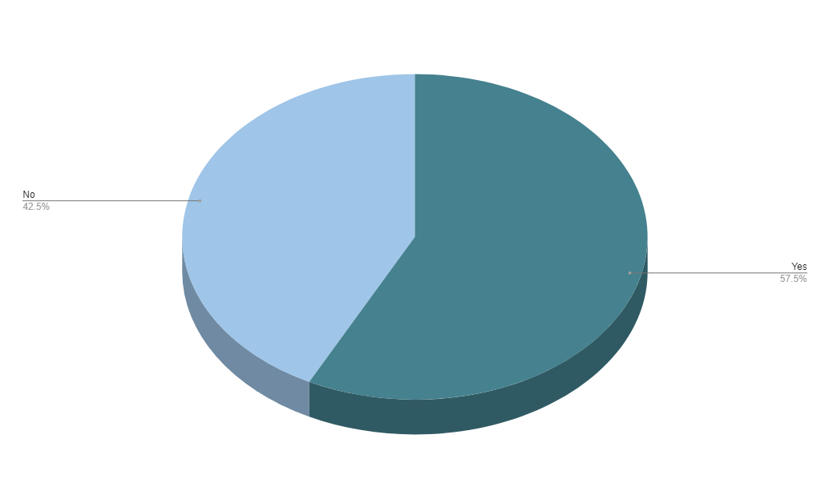

# *Figure 1: Response for Question 1*

1. 67.5% believe routine-based industries are highly susceptible to AI-driven job displacement.

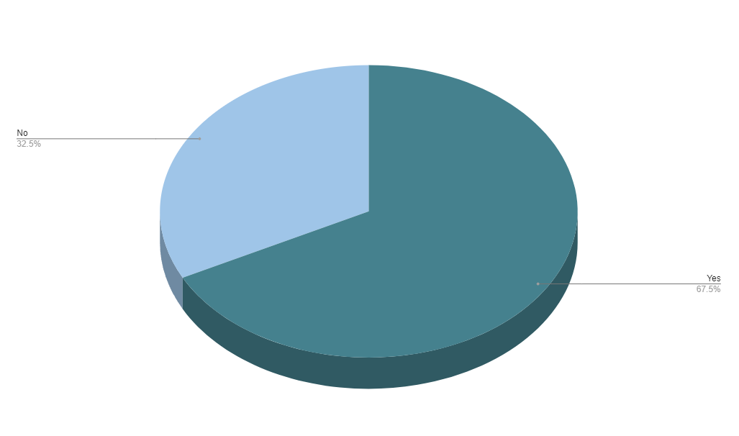

# *Figure 2: Response for Question 2*

1. Reflecting the views of 75%, specific jobs like data entry are notably affected by AI.

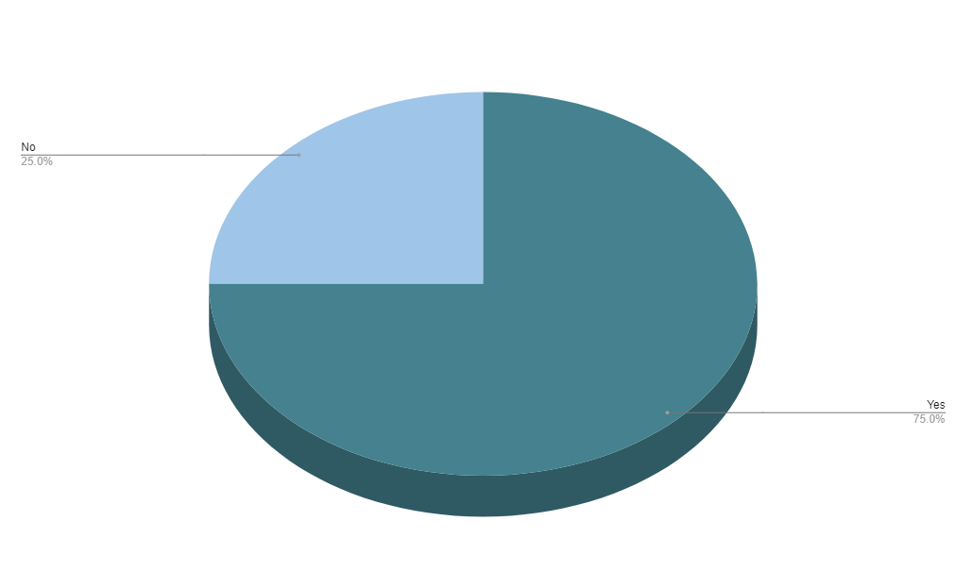

# *Figure 3: Response for Question 3*

1. The debate on AI as a job killer remains divisive, with 47.5% expressing justified concerns.

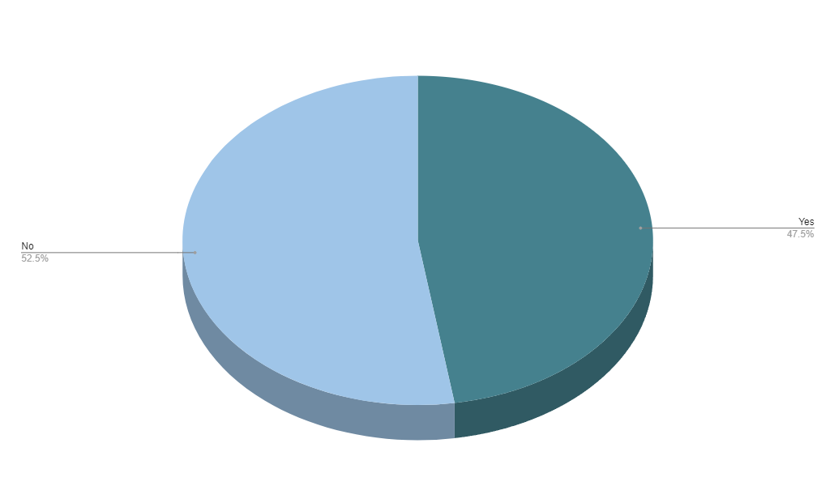

# *Figure 4: Response for Question 4*

1. 72.5% acknowledge AI creates new job opportunities, especially in data science.

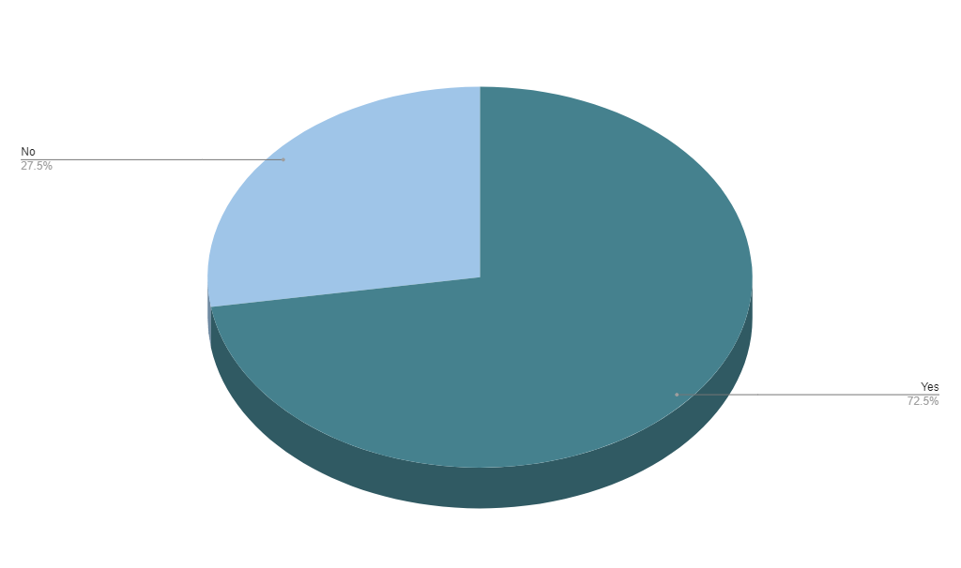

# *Figure 5: Response for Question 5*

1. A strong 87.5% assert workers should proactively acquire skills for AI-driven job changes.

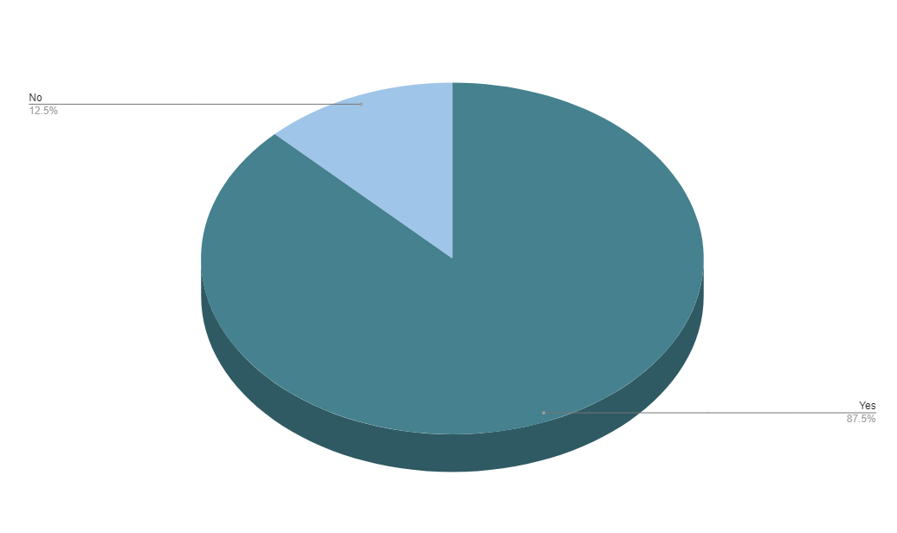

# *Figure 6: Response for Question 6*

1. 67.5% find it difficult to integrate AI into their jobs; 32.5% find it easy.

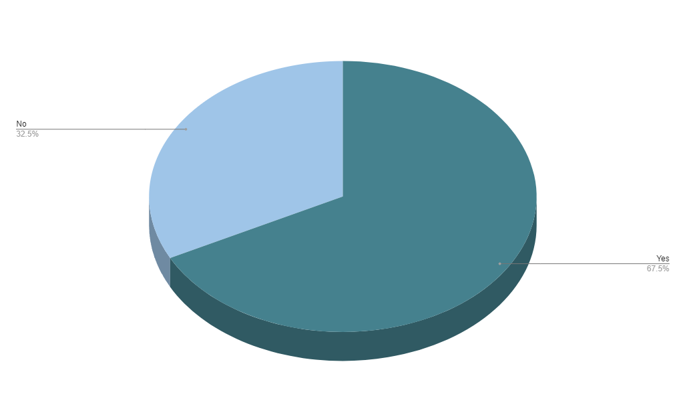

# *Figure 7: Response for Question 7*

1. As AI reshapes industries, 82.5% emphasize the increasing value of adaptability and critical thinking.

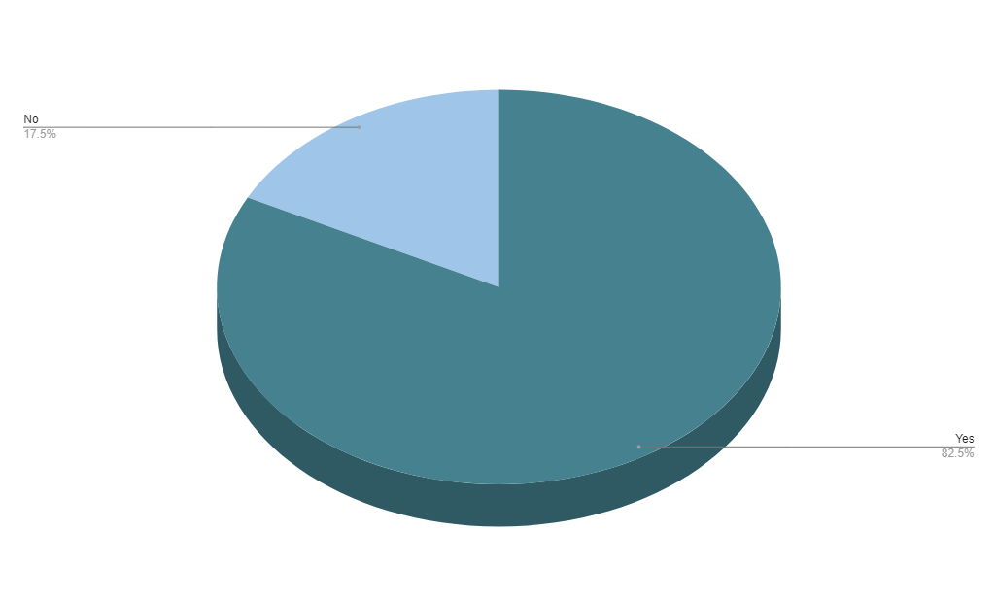

# *Figure 8: Response for Question 8*

1. With 62.5% in agreement, professionals advocate for government policies regulating AI's impact on employment.

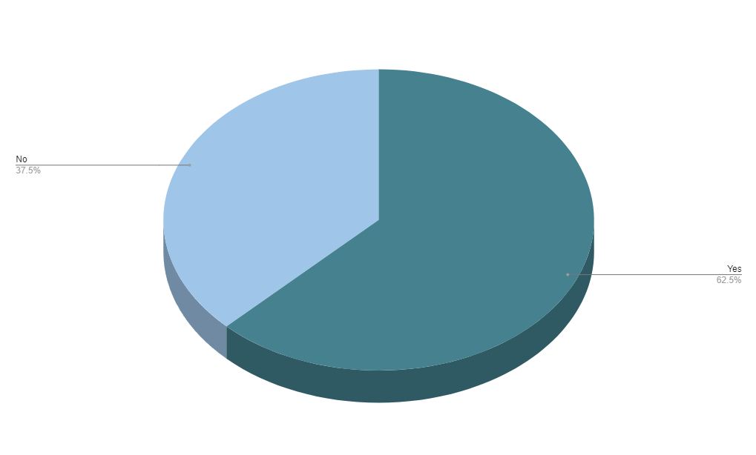

# *Figure 9: Response for Question 9*

1. A resounding 92.5% emphasize the crucial importance of ethical AI development.

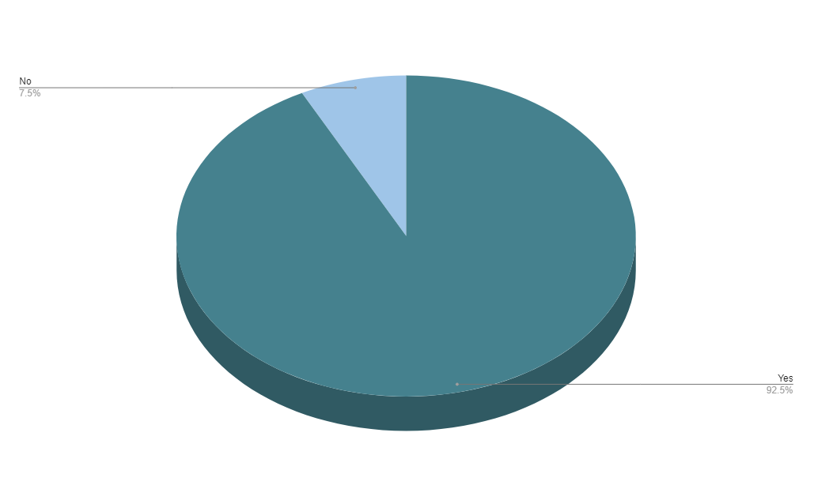

# *Figure 10: Response for Question 10*